**Error: Failed to download module**

**│ on main.tf line 5:**

**│ 5: module "vpc" {**

**│ Could not download module "vpc" (main.tf:5) source code from**

**│ "git::ssh://git@github.com/datkadam/aws_terraform_module.git?ref=v1.1": error downloading**

**│ 'ssh://git@github.com/datkadam/aws_terraform_module.git?ref=v1.1': C:\PROGRAM FILES\GIT\CMD\git.exe exited with 128: Cloning into**

**│ '.terraform\modules\vpc'...**

**│ git@github.com: Permission denied (publickey).**

**│ fatal: Could not read from remote repository.**

**│ Please make sure you have the correct access rights**

**│ and the repository exists.**

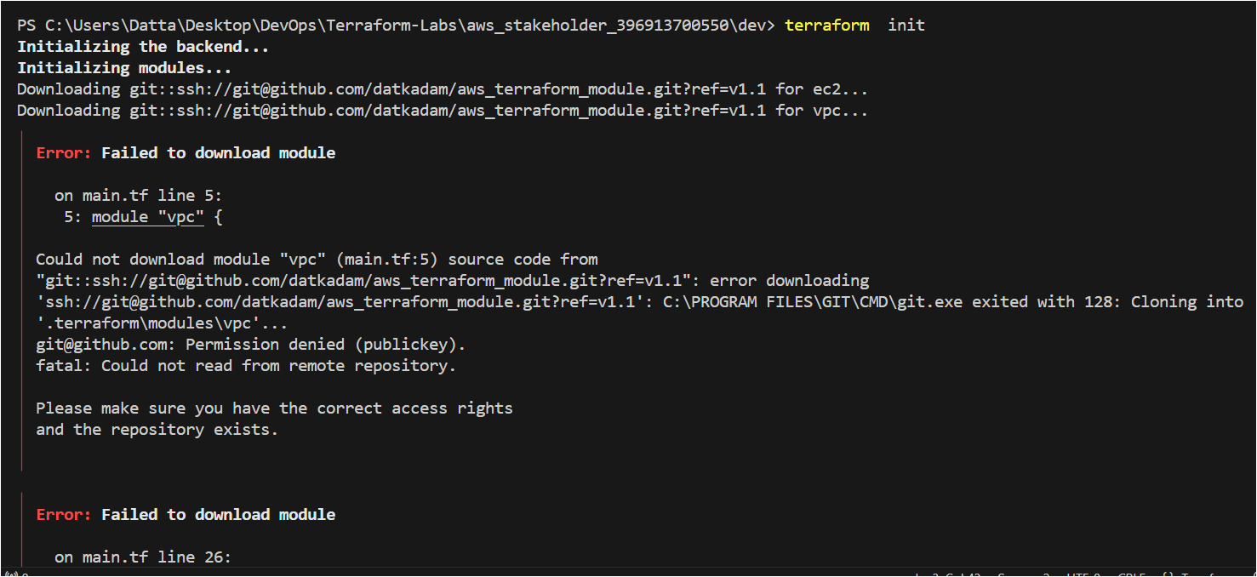

**Generated SSH key for GitHub account and enrolled on local system.**

